“Expert Cloud Consulting” -

SOP | Application Migration
21.Feb.2025
version 1.0
─
Contributed by Tejal Kale
Approved by Akshay Shinde(In Review)
Expert Cloud Consulting
Office #811, Gera Imperium Rise,
Hinjewadi Phase-II Rd, Pune, India – 411057

“Expert Cloud Consulting”

Application Migration

1.0 Contents [ Heading3,14, Arial]

1.0 Contents [ Heading3,14, Arial] 1
2.0 General Information: [ Heading3,14, Arial] 2
2.1 Document Jira/ Github Ticket(s) [ Heading4,12, Arial] 2
2.2 Document Purpose 2
2.3 Document Revisions 2
2.4 Document References 2
3.0 Document Overview: 4
4.0 Steps / Procedure 5
4.1 : Setup the ubuntu server for .net core application 5
4.2: Choose an Amazon Machine Image (AMI) 5
4.3: Key-Pair Configuration 6
4.4: Network settings 6
4.3.1: VPC Configuration: 6
4.3.2: Security Group Configuration 7
4.4: Launch Instance 7
4.5: SSH Configuration 8
4.6: Install SSM Agent on Ubuntu Server 9
5.0 Annexure - I [ heading of content] 11



2.0 General Information: [ Heading3,14, Arial]

2.1 Document Purpose

This document provides a step-by-step guide to migrating Windows-based Virtual Machines (VMs) from Microsoft Azure to Amazon Web Services (AWS) using AWS Application Migration Service (AWS MGN).

2.2 Document Revisions

Date | Version | Contributor(s) | Approver(s) | Section(s) | Change(s)
09/Aug/2024 | 1.0 | Tejal Kale | Akshay Shinde | All Sections | New Document Created

3.0 Document Overview:

This document provides a detailed step-by-step guide for migrating Windows Virtual Machines (VMs) from Microsoft Azure to Amazon Web Services (AWS) using AWS Application Migration Service (AWS MGN).

The migration process ensures a seamless, secure, and minimal-downtime transition while maintaining data integrity and application functionality.

4.0 : Create a Resource Group in Azure
A Resource Group in Azure is a container that holds related resources.
We will create one to organize our migration-related resources.

4.1 : Steps to Create a Resource Group:
Login to Azure Portal
- Go to Azure Portal.
- Sign in with your Azure account.
Navigate to Resource Groups
- In the Azure Home Dashboard, search for Resource Groups in the search bar.
- Create a New Resource Group.

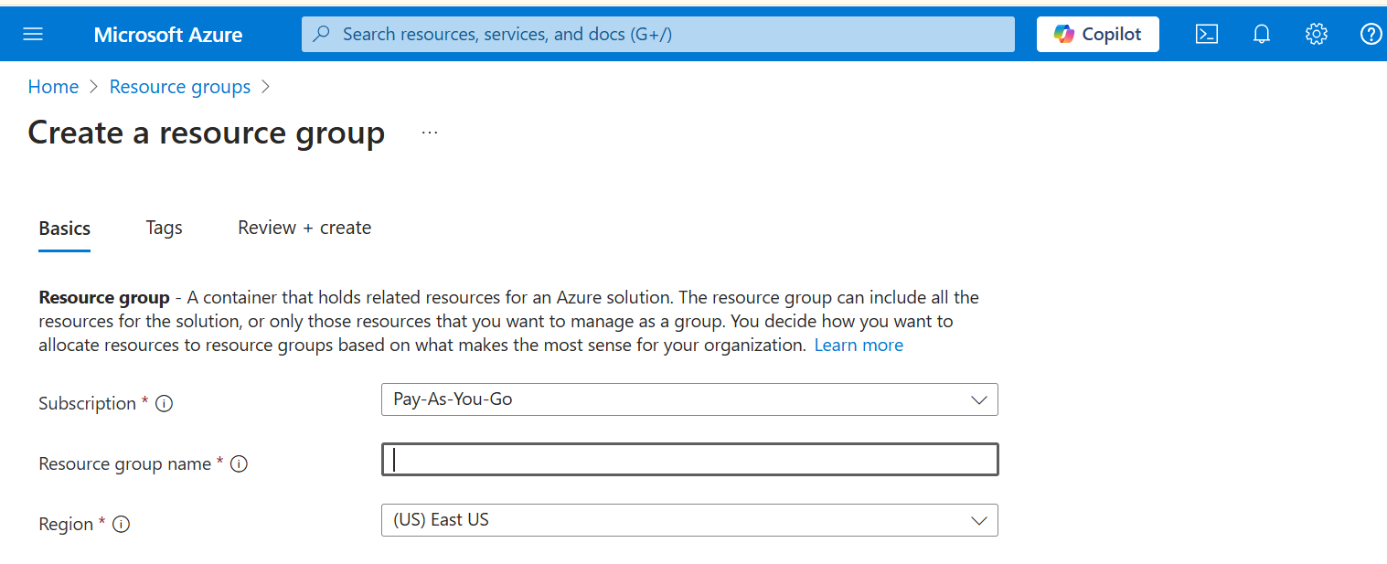

5.0: Prepare Azure VMs for Migration
1. Go to Azure Portal
- Log in to Azure Portal.
- Search for Virtual Machines in the search bar and click on it.
2. Click on "Create" → "Azure Virtual Machine"
3. Configure the Virtual Machine Basics
Fill in the required details:
- Subscription: Select your Azure subscription.
- Resource Group: Choose the Resource Group you created earlier.
- Virtual Machine Name: (Example) MyWindowsVM
- Region: Select the same region as your Resource Group.
- Availability Options (Optional): Can be left as default or select as per requirement.
- Security Type: Standa
4. Select the OS Image
- Image: Choose Windows Server 2019
5. Select VM Size
Click on "Change Size" and select Standard B2s (2 vCPUs, 4GB RAM).
Click "Next" or "Review + Create" to proceed with further configurations.

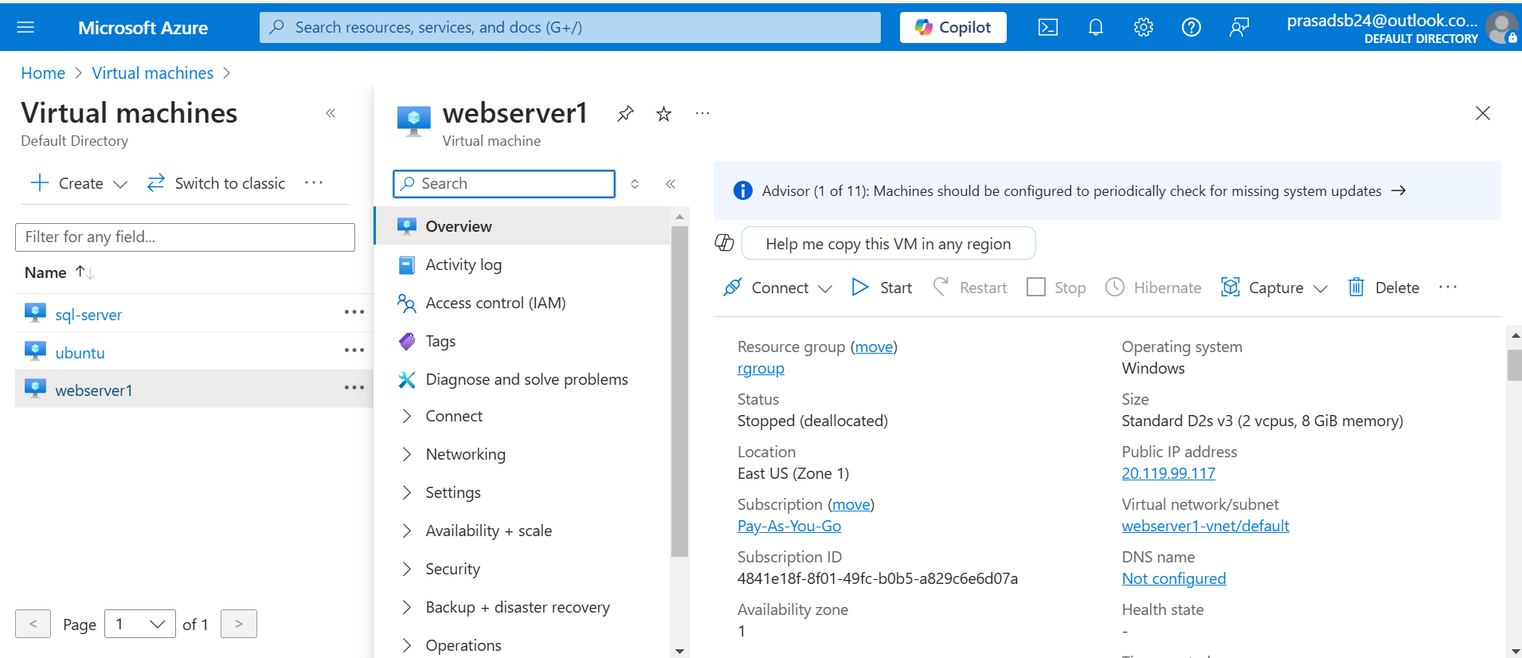

6.RDP into windows VM
Goto the connect section in settings and Download the RDP file as shown below:
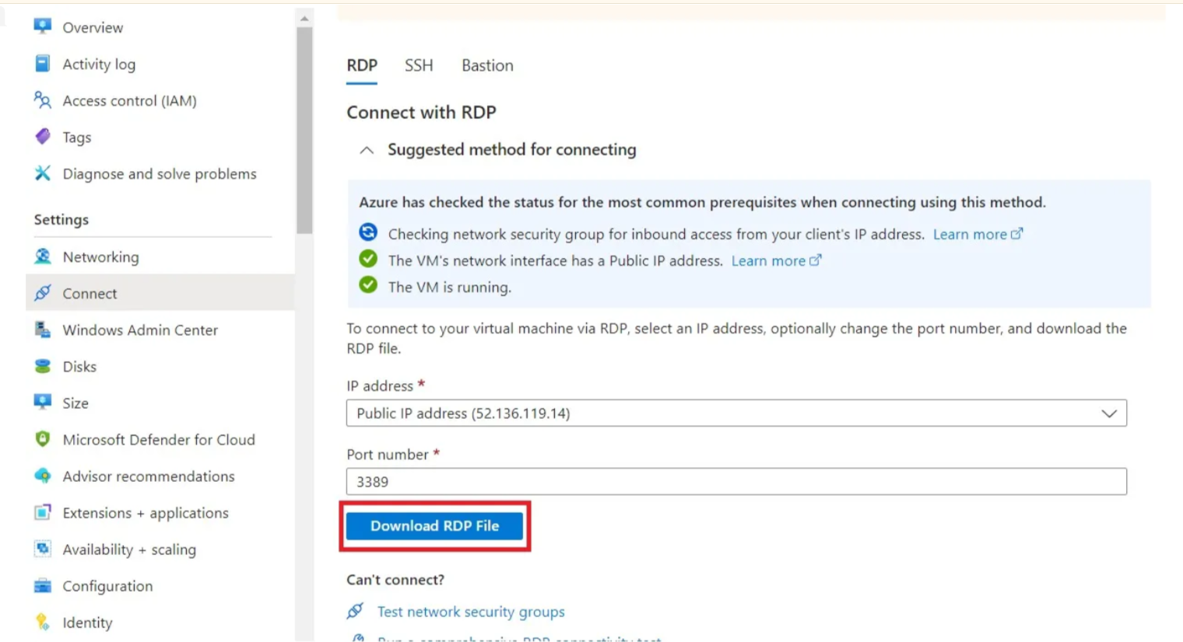

7.After Authentication you should see this kind of interface shown below:

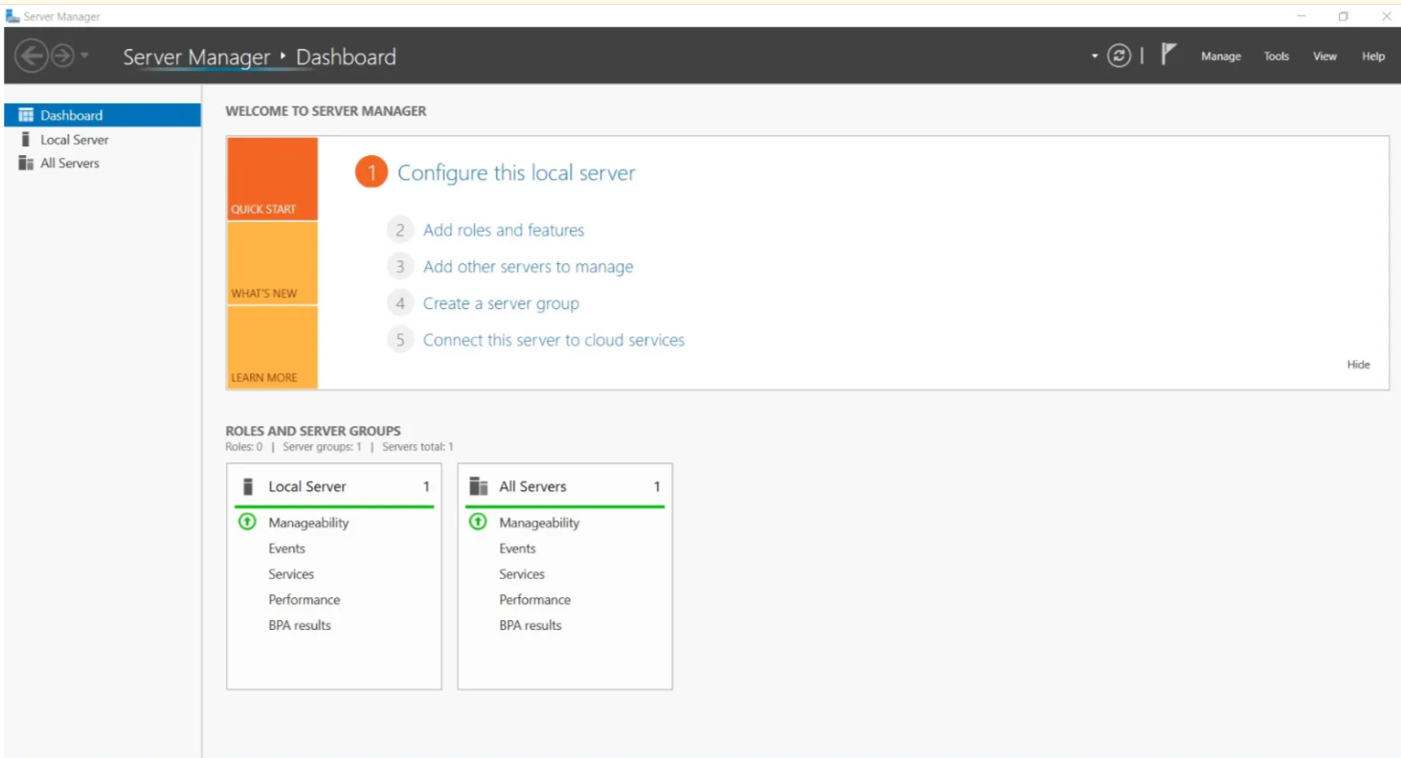

8. Goto local server and disable IE enhanced security configuration

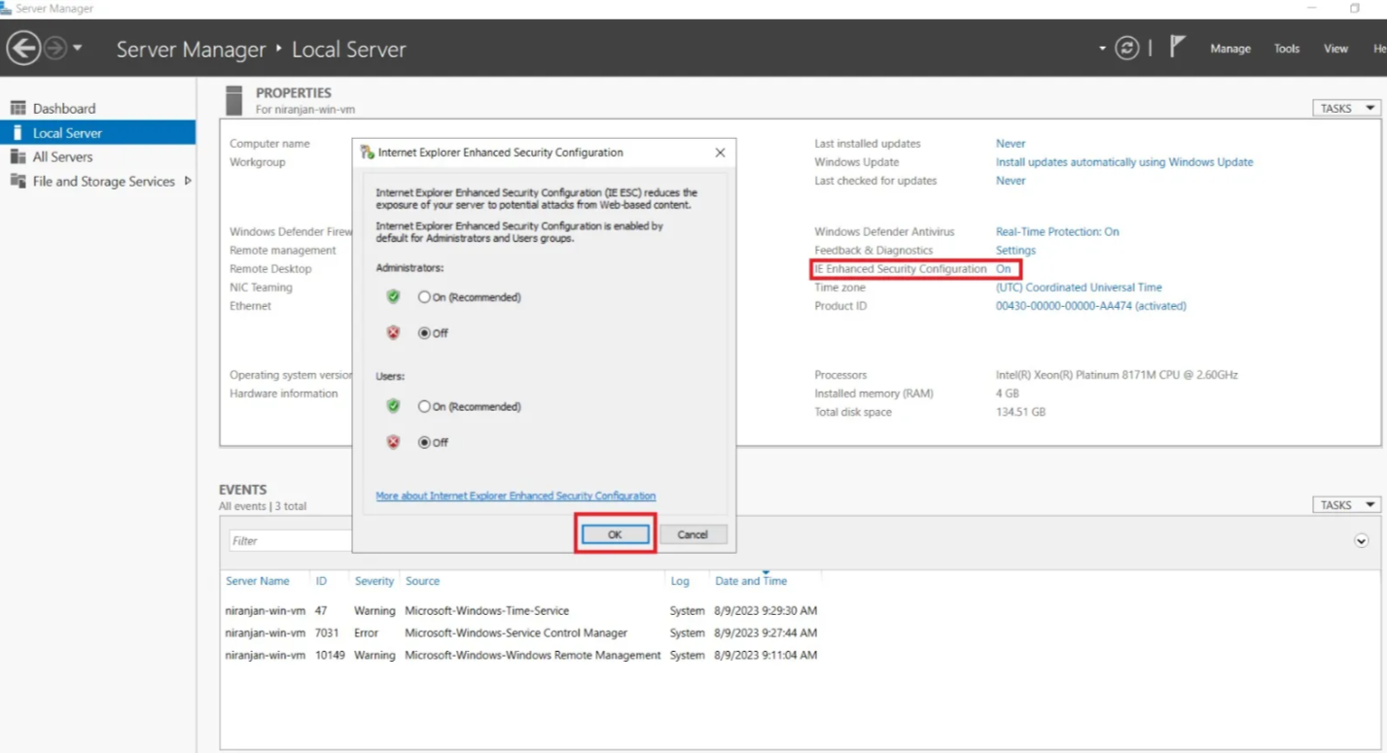

6.0 Download Nginx for windows

After downloding nginx extract the zip file in C drive. After that go to your browser and type https://localhost:80 and you should see as shown below:

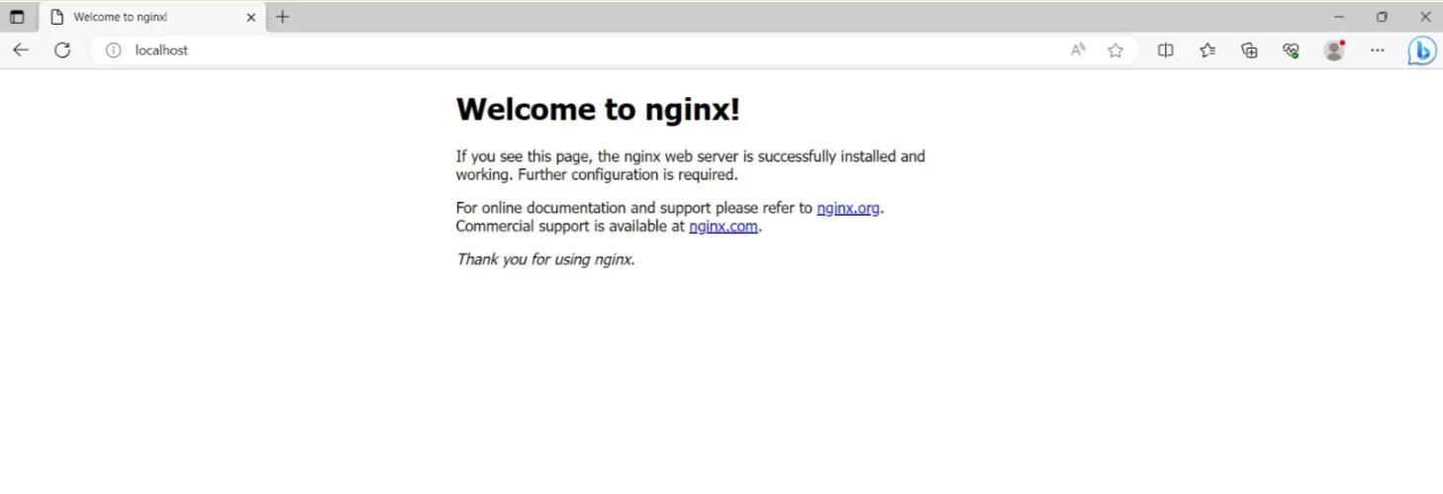

6.1 : Expose your nginx to the outside world

To do that go to your azure vm , In settings click networking and select inbound rules and click add inbound rule

Source: Any

Destination: Any

Service: HTTP

Action : Allow
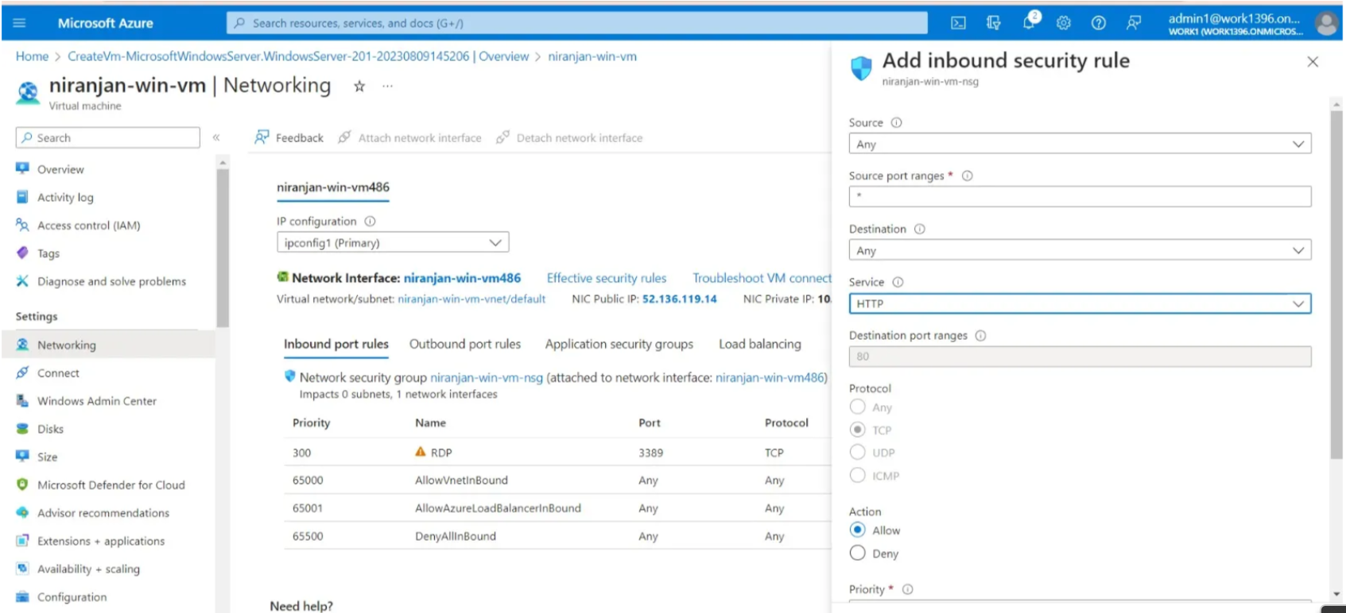

6.2 : in the AWS side search For Application migration service So we will talk more about the settings part where first we need to configure the launch template and replication template

Replication template — Replication settings determine how data will be replicated from your source servers to AWS. Your replication settings are governed by the replication template, which you must configure before adding your source servers to AWS Application Migration Service. You can later edit the replication settings at any point. The settings configured in the replication settings template are then transferred to each newly added server.

Launch template — The Launch template allows you to control the way AWS Application Migration Service launches instances in AWS. The default configuration defined in the template will be automatically applied to every newly added server.

You can change the settings for existing and newly added servers individually within the source server details view, Launch settings tab. Changes made to server launch settings will only affect the selected server and will not affect the launch template.

To edit the launch template for your entire account, you will need to edit your Launch template. Choose the Launch template from the left-hand navigation menu.

Post-launch template — Post-launch settings allow you to control and automate actions performed after the server has been launched in AWS. These settings are created automatically based on the Post-launch template.

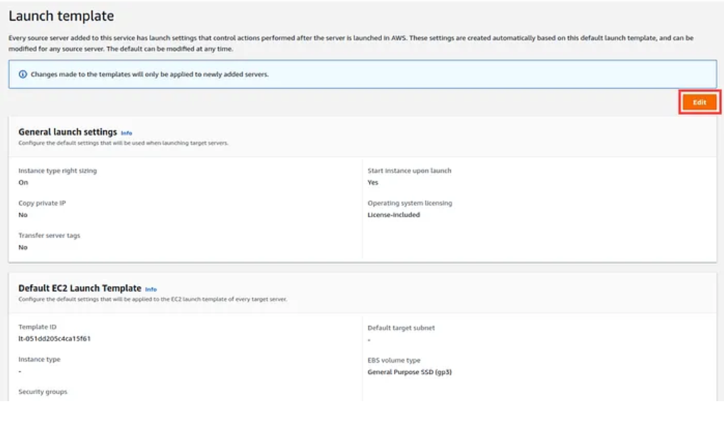

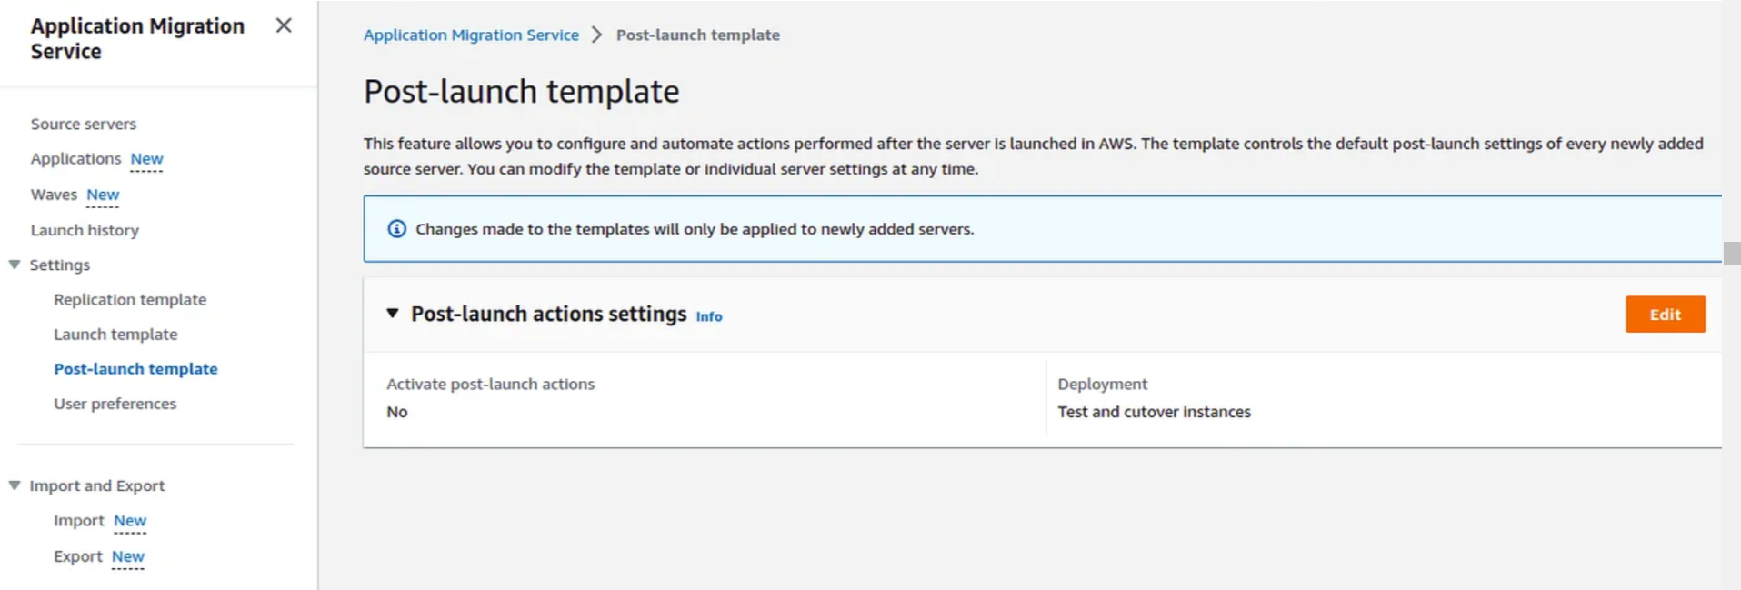

6.3 After setting up your Replication and launch template server
we will move forward to the source server where we will add our Azure(windows) source vm Add Server.

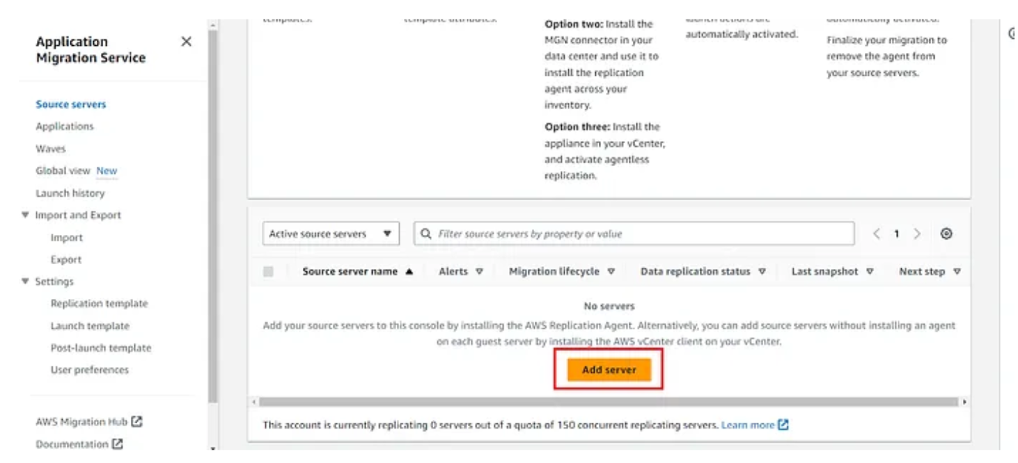
- Select your operating system — Windows
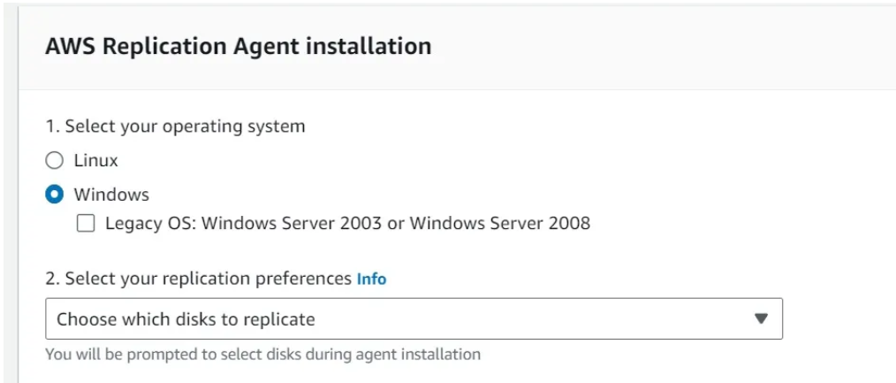

Go to AWS IAM Section create 1 user add permission as AWSApplicationMigrationAgentInstallationPolicy
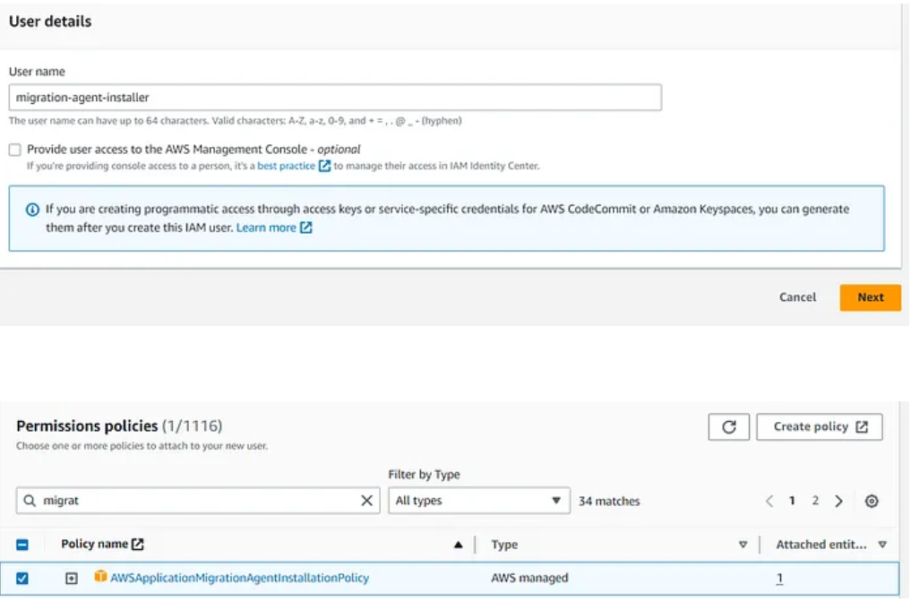

- Create user
Go to the security credential section and generate the Access key like this mention below screenshot Now copy the access key and Secret key and paste into the Application migration server section.
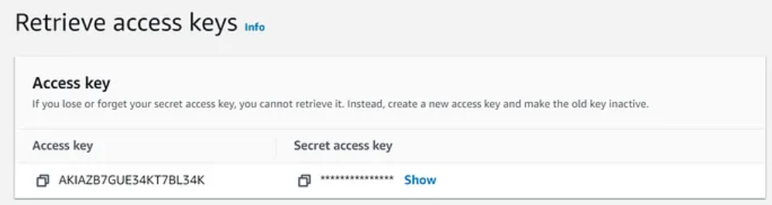

Now copy the link of Installer agent and paste it into browser of windows vm as shown below:


This will download the agent
Open the windows cmd prompt as Administartor.

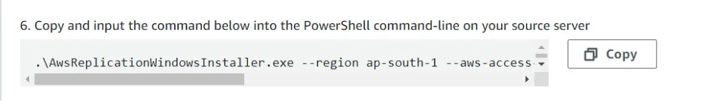
While installing the agent you will face an issue as shown below:
After this go to aws application migration service and you should see that a server will be created automatically as shown below:

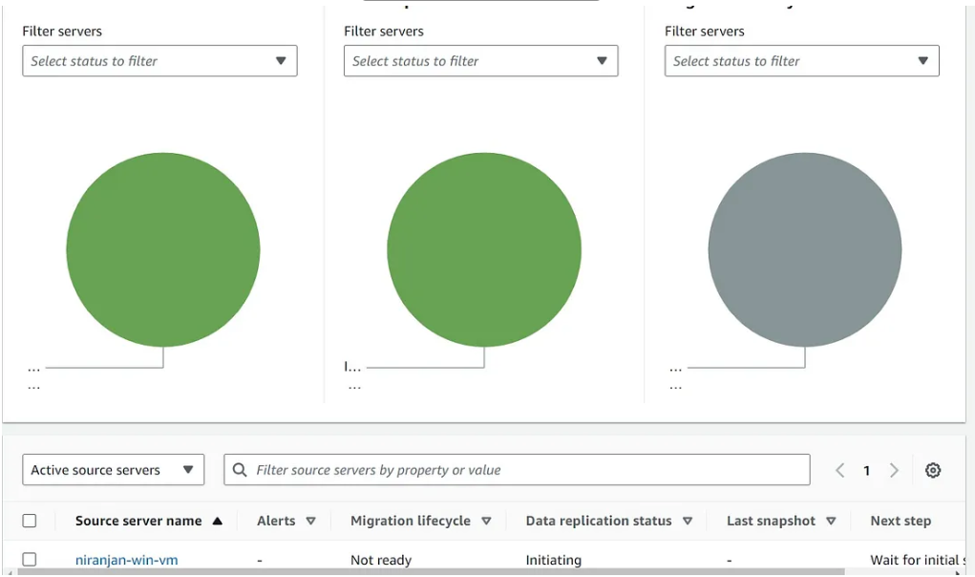

Now this will create Replication server this is Responsible for creating snapshot and volumes of source Vm as shown below:
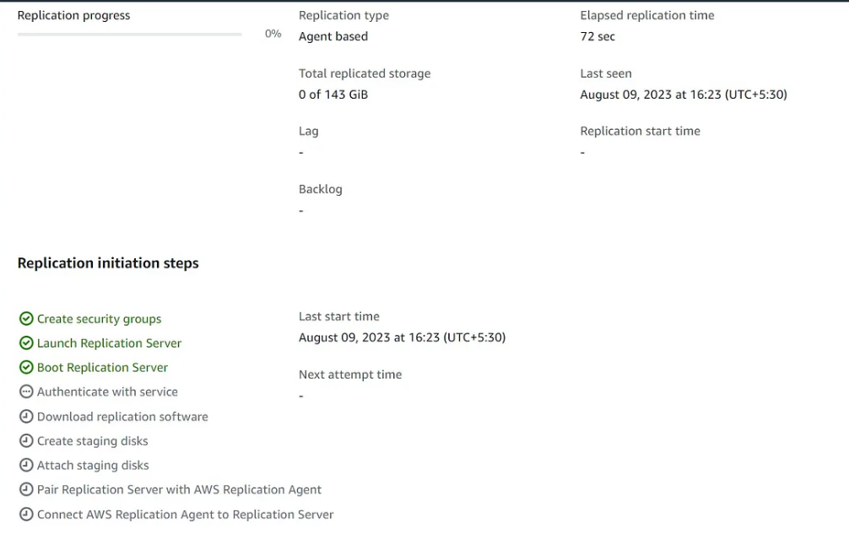

In this an instance of Replication server will be created automatically as shown below
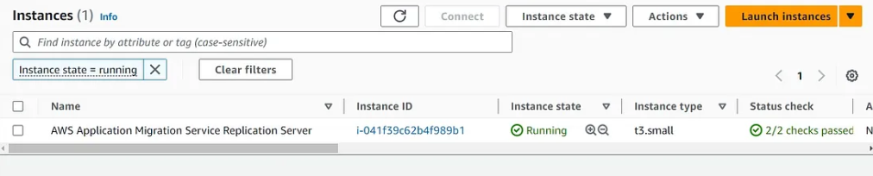

After this Replication server will create snapshot and ABS volumes and replicate all your data into it as shown below:
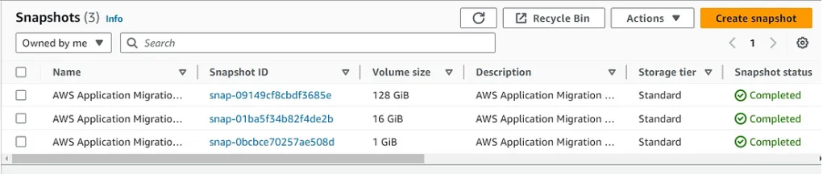

It will take some time to get data replicated
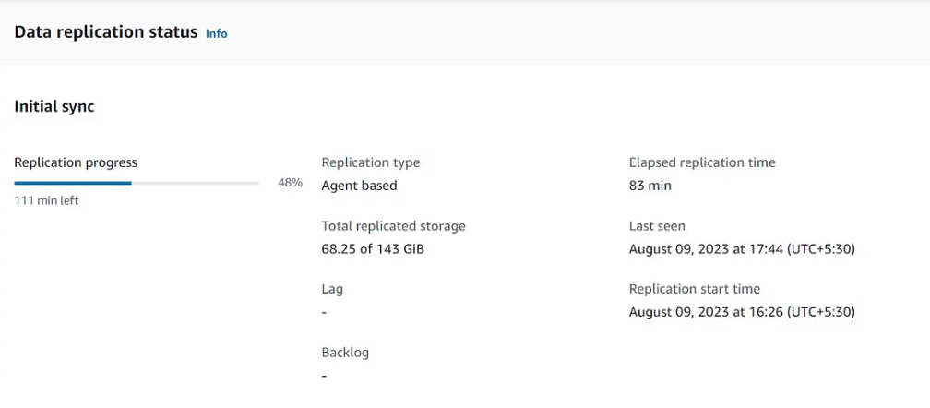

After replication progress completes to 100% then click on test and cutover option on the top right side of the console
In that click on Launch Test instance as shown below:
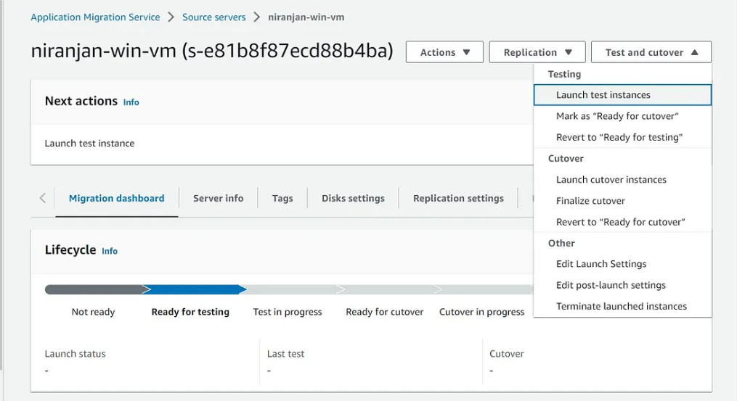

In my case i will not test my data i will directly move to Cutover section
But its Good to test your data in test vm while you are working in Production server.
You can See my test vm is ready i will mark it as Ready to Cutover as shown below:
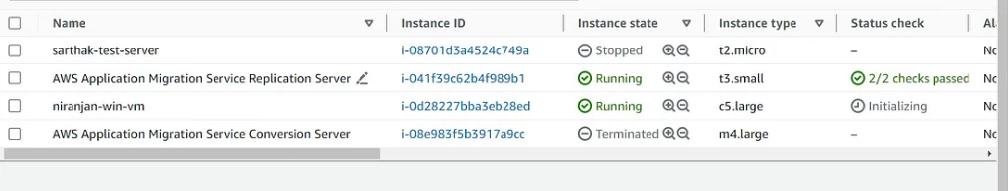

After that click on Launch cutover instances in Test and cutover section as shown below:

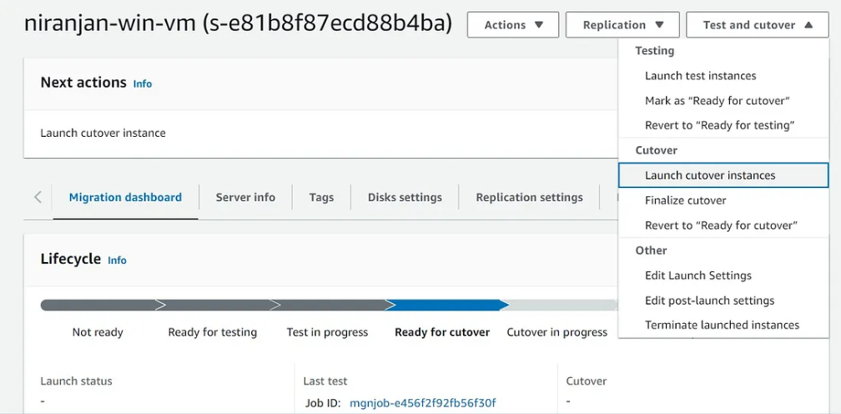

You can also See logs by clicking Event and Metrics as shown below:
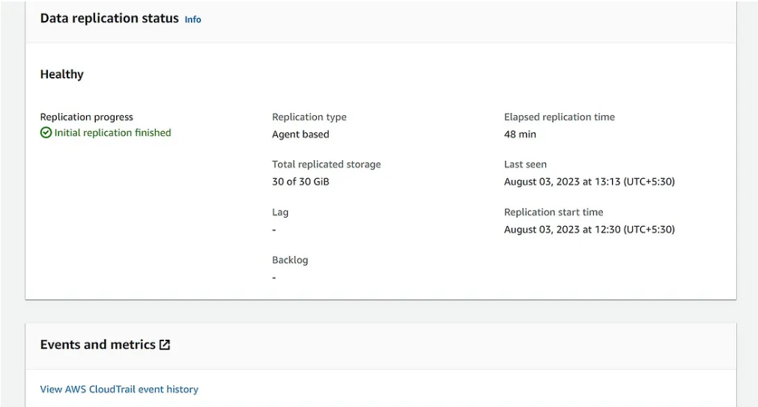

Finalize Your cutover
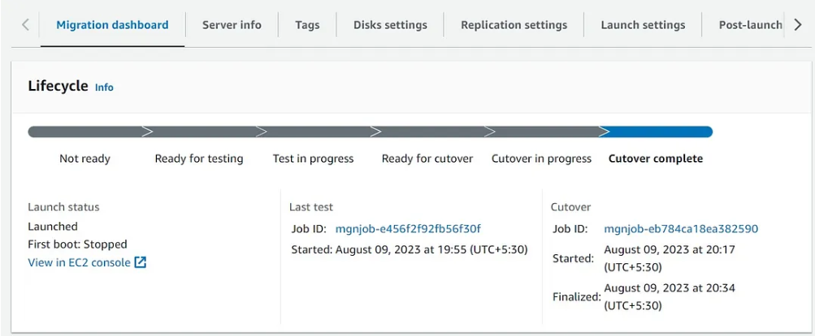

The cutover has been completed as shown above
Download the new RDP file and choose an use an different account and enter your credentials that you have given while creating your Azure VM as shown below:


After hitting the IP in the browser you should see welcome to nginx page on your browser as shown below:
